Event no: VII
Title of the Activity
Workshop on Additive Manufacturing and Technologies
Type of Activity
Hands-on Technical Workshop under AICTE IDEA Lab
Organizing Unit
AICTE IDEA Lab
Date & Venue
- Dates: 19-11-2025 and 20-11-2025
- Venue: AICTE IDEA Lab
Objective of the Activity
The objective of the workshop was to:
- Provide in-depth knowledge of additive manufacturing (3D printing) principles and technologies
- Train students in design, material selection, and fabrication processes
- Enable hands-on exposure to rapid prototyping tools available in the AICTE IDEA Lab
- Encourage students to apply additive manufacturing in product development, innovation, and startups
Participants
- Students from Mechanical, EEE, ECE, CSE, IT, and allied branches
- Faculty members and IDEA Lab coordinators
Description of the Activity
As part of the AICTE IDEA Lab initiative, a two-day workshop on Additive Manufacturing and Technologies was conducted on 19th and 20th November 2025. The workshop covered fundamentals of additive manufacturing, various 3D printing technologies, materials used, design considerations, and applications across engineering domains. Participants were trained in preparing 3D models, slicing, machine operation, and post-processing techniques. Hands-on sessions enabled students to fabricate components using 3D printers available in the IDEA Lab, emphasizing rapid prototyping and iterative design.

Role of AICTE IDEA Lab
- Provided advanced additive manufacturing infrastructure
- Enabled experiential and project-based learning
- Supported interdisciplinary innovation and prototype development
- Served as a platform for translating ideas into physical prototypes
Outcomes of the Activity
- Enhanced understanding of additive manufacturing technologies
- Improved practical skills in 3D modeling and prototyping
- Increased student confidence in using IDEA Lab facilities
- Identification of applications for projects, research, and startup ideas
- Promoted innovation-oriented and hands-on learning culture
Impact
The workshop significantly strengthened students’ capabilities in modern manufacturing technologies and reinforced the role of the AICTE IDEA Lab in fostering innovation, design thinking, and skill development.
Conclusion
The two-day workshop on Additive Manufacturing and Technologies successfully achieved the objectives of the AICTE IDEA Lab Scheme by promoting experiential learning and advanced technical skills. Such activities contribute to building a strong foundation for innovation, product development, and entrepreneurship at Swarnandhra College of Engineering & Technology.
Gallery
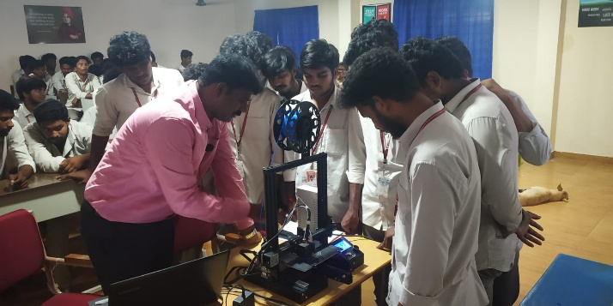 | 